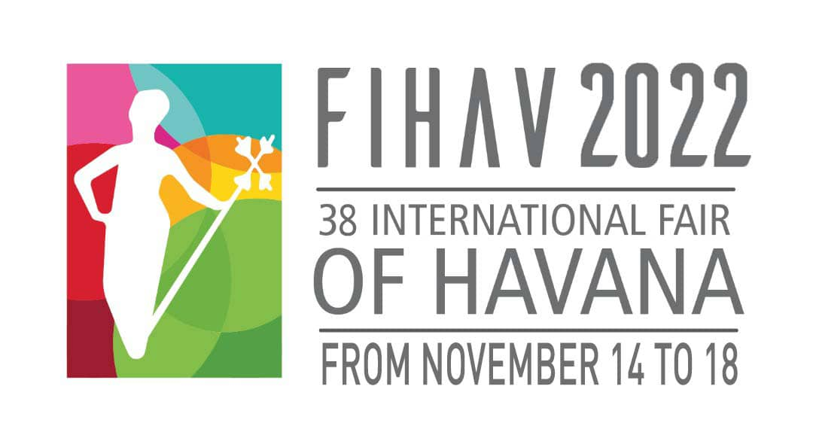
Ladies and Gentlemen,
The Organizing Committee of the Havana International Fair, FIHAV, is pleased to invite you to participate in its XXXVIII Edition, which will be held from November 14 to 18, 2022, at the EXPOCUBA fairgrounds.
FIHAV is the most important general commercial exchange in Cuba and the Caribbean, and one of the most representatives in Latin America.
The Havana International Fair has been held since 1983, resulting in an excellent business platform for new companies in the market and for those already established. Its magnitude and importance are given by being a space with the most complete national commercial sample.
In the years 2020 and 2021 it was not possible to celebrate this traditional event due to the health situation created by the COVID-19 pandemic in Cuba and the world. Today, the situation is different. Thanks to our scientists and the integrity of our health system and personnel, the control of the pandemic in Cuba is a real prospect.
Despite the economic, commercial and financial blockade of the United States government against our country, intensified in times of pandemic, we have, as always, the confidence of businessmen from all over the world in the Cuban market, for which we hope a wide participation in this new edition of the Fair.
Exhibitors, businessmen and technicians from all sectors of the Cuban economy will converge at the Fair's headquarters for five days; and a wide and varied international commercial sample. It will be a suitable space for the development of business meetings, business rounds, seminars and conferences, among other activities.
Within the framework of FIHAV 2022, we will celebrate the V Investment Forum which, judging by its previous editions, will be an excellent opportunity to hold bilateral meetings between Cuban and foreign businessmen, potential foreign investors; as well as, to continue sharing ideas and exchanging on the challenges that lie ahead in terms of attracting investment.
Activities to promote Cuban exportable funds will also be carried out, which will include the productions of non-state forms of management present at the event. As usual at the Fair, there will be various business forums, and the delegations of each country will be able to celebrate National Days in their pavilions.
In the same way, a virtual business forum will be held again, which will allow interaction with businessmen who do not travel to Cuba on this occasion.
At FIHAV we guarantee interesting and fruitful work sessions, as well as unforgettable moments during your stay in Cuba.
We are waiting for you at the International Fair of Havana.

RODRIGO MALMIERCA DIAZ
Minister of Foreign Trade and Foreign Investment
President of the FIHAV Organizing Committee

GENERAL INFORMATION
XXXVIII INTERNATIONAL FAIR OF HAVANA - FIHAV 2022

DATE: 14 to 18 November, 2022
OPENING HOURS: 10:00 – 17:00
VENUE: Expocuba fairground (Carretera del Rocío Km 3½, Arroyo Naranjo)

ORGANIZING COMMITTEE
- Ministry of Foreign Trade and Investment
- Chamber of Commerce of the Republic of Cuba
- PALCO Business Group

EXHIBITOR’S PROFILE: FIHAV is a multi-sector trade fair with raw materials, foodstuffs, textiles, consumer goods, machinery and equipment, technology and services as its main areas.
The participating enterprises are grouped by countries. Depending on the area required, they may have part of a pavilion, an entire pavilion or several pavilions.

GENERAL PROGRAM
2 to 13 November  9:00 a.m. - 5:00 p.m. | Mounting of free design stands (accredited personnel with previous coordination with the Organizing Committee).
9 to 13 November  9:00 a.m. - 5:00 p.m. | Accreditation of exhibitors.  Mounting of modular stands.
Monday, November 14  10:00 am.  12:00 m. - 5:00 p.m. | Opening Ceremony. Plaza de las Banderas.  Professional visits.
Tuesday, November 15  10:00 a.m. - 5:00 p.m.  10:00 a.m. - 5:00 p.m. | V Investment Forum.  Professional visits.
Wednesday, November 16  10:00 a.m. - 5:00 p.m.  10:00 a.m. - 5:00 p.m. | V Investment Forum.  Professional visits.
Thursday, November 17  10:00 a.m. - 11:00 a.m.  11:00 a.m. - 12:00 m.  10:00 a.m. - 5:00 p.m. | Presentation of the Business Intelligence Portal.  Presentation on Cuban exportable funds.  Professional visits.
Friday, November 18  10:00 a.m. - 5:00 p.m.  11:00 a.m. - 5:00 p.m.  7:00 p.m. | Professional visits.  Admission of general public.  Awarding Ceremony. Palacio de Convenciones de La Habana.
Saturday, November 19  9:00 a.m. – 5:00 p.m. | Withdrawal of samples
21 to 25 November  9:00 a.m. – 5:00 p.m. | Withdrawal of samples and dismounting of stands

Other activities:
Presentation of the Single Window for Foreign Trade.
Business forum with Cubans residing abroad.
Meeting of Chambers of Commerce and business committees.

The Expocuba fairground is Cuba’s largest exhibition center. It is located on the highway Carretera del Rocío, Km 3 ½, in the municipality of Arroyo Naranjo. It lies some 25 Km southeast of downtown Havana. It has an area of 600,000 m², 25,000 m² of net exhibition area and 25 pavilions for exhibitions.

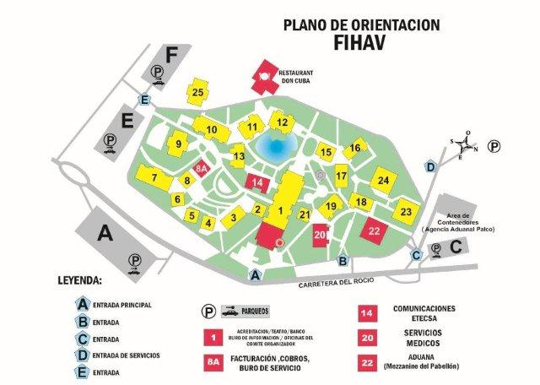

ENGAGEMENT OF EXHIBITION AREA: The participation will be made official using the form Contract Request of Participation form, to be requested by addressing pabexpo1@palco.cu y luisgutierrez@palco.cu or directly at Pabexpo with deadline October 14.

The form Contract Request of Participation will be delivered with the complete information, including the design of the stand, otherwise the Organizing Committee will not be responsible for the non-fulfillment of any of the requirements made by the applicant. It is indispensable that this Contract Request of Participation is approved and signed by the Fair Organizer.

To confirm your reservation and receive your location, the exhibitor must pay 50% of the cost of the area contracted at the time of formalizing the request. The deadline for payment of the remaining 50% of space and contracted services will be 20 days before the start of the Fair.

In the case that the samples to be exhibited in the Interior Area have large dimensions, weight or other special characteristics, the exhibitor must notify the Organizer not less than 20 days before the opening of the Fair, in order to obtain his or her evaluation and approval, in attention to the specifications of assembly, coordination for its access to the pavilions and requirements of the fairground.

All changes in the distribution of panels or any other element related to the assembly of the stands will be charged additionally, according to their complexity and proximity to the opening date of the Fair.
The Organizing Committee reserves the right when it deems it appropriate for the interests of a competition to make changes in the location of the stands and to communicate it to the exhibitor together with the proposal of the new location.

A surcharge of 20% will apply for all services required once the general assembly of the fair has begun.
WAIVER OR REDUCTION OF PARTICIPATION: The waivers or reductions of the original contracted space entail penalties, even when the space may be occupied for another exhibitor.
- Up to 30 days prior to the Fair - 50% of contracted space
- Up to 7 days or less prior the beginning of the Fair - 100% of contracted space.

TARIFFS:

- Indoor stand, mounted
Tariff: CUP 2640.00/m² (from 9 m² on, minimum to contract)
Includes: space, aluminum structure, white modular panels (2.42 x 0.95 m), carpet, sign with exhibitor’s name, power consumption up to 500W, cleaning, protection of samples, credentials (according to the rented area) and entry in the official catalogue (up to 15 lines).

- Indoor stand, mounted (Mezzanine)
Tariff: CUP 2400.00/m² (from 9 m² on, minimum to contract)
Includes: space, aluminum structure, white modular panels (2.42 x 0.95 m), carpet, sign with exhibitor’s name, power consumption up to 500W, cleaning, protection of samples, credentials (according to the rented area) and entry in the official catalogue (up to 15 lines).

- Indoor stand, not mounted (WITHOUT CARPET)
Tariff: CUP 2400.00/m² ⁽from 9 m² on, minimum to contract)
Includes: space, power consumption up to 500W, cleaning, protection of samples, credentials (according to the rented area) and entry in the official catalogue (up to 15 lines)

- Indoor stand, not mounted (Mezzanine) (WITHOUT CARPET)
Tariff: CUP 2160.00/m² ⁽from 9 m² on, minimum to contract)
Includes: space, power consumption up to 500W, cleaning, protection of samples, credentials (according to the rented area) and entry in the official catalogue (up to 15 lines)

- Indoor stand, not mounted (with Special Assembly) (WITHOUT CARPET)
Tariff: CUP 3600.00/m² ⁽from 9 m² on, minimum to contract)
Includes: space, power consumption up to 500W, cleaning, protection of samples, credentials (according to the rented area) and entry in the official catalogue (up to 15 lines)

- Outdoor space

Tariff: CUP 1440.00/m² (from 9 m² on, minimum to contract)
Includes: space, power consumption up to 500W, cleaning, protection of samples, credentials (according to the rented area) and entry in the official catalogue (up to 15 lines)

HOW TO PAY: All tariffs are expressed in Cuban pesos (CUP); therefore, the exhibitor must obtain information about the rate exchanges in force in Cuba. Payments in US dollars (USD) are not accepted.
- Payments must be done by Bank Transference or Check (It will not be admitted from the account titled FINESP). Payments will be directed to:
- Holder: Empresa Organizadora de Congresos, Ferias y Exposiciones
Account number: 0300000005628911
Name of bank: Banco Financiero Internacional BFI
Bank address: Ave. 5ta. Esq. a 92, Playa
Code: SWIFT: BFICCUHH

- Payment in CUP cash or credit card (VISA International, MASTERCARD, CABAL or BFI)
- Directly at PABEXPO’s Department of Finances.
- Once the mounting stage has begun you may address Pavilion 8-A in EXPOCUBA.
PROFESSIONAL VISITOR: Businessmen, entrepreneurs, buyers, professionals and interested in visiting the Fair can be accredited as professional visitors at a cost of 2400.00 CUP. This accreditation includes: the right to visit the Fair every day, an official catalog, participation in official activities such as the opening and awards ceremonies and to establish commercial contacts.
They can register and pay directly with the Finance Department of PABEXPO or at the time of arriving at Expocuba Fairground in the VIP Room located in the Central Pavilion.

REGISTRATION: The number of name badges per exhibiting firm is subject to the size of exhibition space requested as follows. The exhibitor can register additional personnel at a cost of $960.00 CUP each.
- 9 m² to 16 m²: 3 Name Badges
- 18 m² to 30 m²: 4 Name Badges
- 32 m² to 50 m²: 5 Name Badges
- 51 m² to 80 m²: 6 Name Badges
- 81 m² to 100 m²: 8 Name Badges
- More than 100 m²: 10 Name Badges

The name badge is for personal use only and not transferable to any other person. FIHAV authorities have the right to withdraw a name badge as a result of improper use; therefore if the exhibitor wants to remain in the Fair will have to pay $960.00 CUP for a new name badge.

MOUNTING RIGHTS: Companies and individual persons who work in the decoration and / or assembly must pay a fee of 2100.00 CUP per credential and in the case of special assemblies 2880.00 CUP. The credentials for the assembly and disassembly will only give access to the pavilion indicated and during these stages. The improper use of them entitles the authorities of the Fair to withdraw them and prohibit the entry of the persons involved.

The schedules and days of the assembly stage are those set by the Organizing Committee and when it is required, in an exceptional manner, they will be extended for the exhibitors' needs and the additional time will be invoiced in accordance with the established tariffs. At any time the request for additional time will be communicated to the Organizer with not less than 24 hours before the date you want to work out of the established time.

OFFICIAL CATALOGUE: The Fair publishes an official catalogue of its exhibitors that includes all the exhibiting companies in alphabetical order by country and by classification of the products that are exposed, as the case may be. The exhibitor has the right to include up to 15 lines of text in the products and / or services of his company. Attention should be paid to the information to be published, because the information used will be the one that comes exclusively from the data provided by the exhibitors, it must be delivered in digital or printed format and clearly drafted. The Organizing Committee is not responsible for errors or omissions and it will make the necessary arrangements in those cases that do not correspond with the form and style of the Catalogue.
Also the exhibitor will have the possibility of including advertising in this catalog, according to the established tariffs. The originals must be sent to the Organizer ready for printing (final art), in PDF format and dimensions of 16 x 22 cm.

The deadline to send information for the official catalog as well as for advertising is 24 days before the start of the Fair.

SAMPLES FOR EXHIBITION AT FIHAV: Agencia Transitaria PALCO is the official FIHAV forwarding and customs dispatch agency. All the information concerning arrival terms of goods, and documents required for customs dispatch may be obtained from:
- Agencia Transitaria Palco: Address: Calle 180 esq.15 Rpto. Siboney, Playa, Apartado Postal 16046, La Habana, Cuba. Telephone: (53) 7271 3669 / E-mail: lianetfernandez@palco.cu

AWARDS JURY: FIHAV has an award system
- Design Award of the Organizing Committee of FIHAV for Modular Stand and Free Design
- Special Awards from the Organizing Committee of FIHAV
- Gold Medal of the National Office of Normalization for the Quality of the Product
- Award from the National Design Office for Product Design
- Communication Award of the Cuban Association of Social Communicators

VISAS: The exhibitors and participants of the Fair should travel to Cuba with a tourist visa acquired in their own countries consulate.
SERVICES TO EXHIBITORS AT EXPOCUBA: The Organizing Committee offers the following services to the exhibitors:
- Organization of a business round
- Trade information bureau
- Programs of conferences, seminars
- Design, decoration and mounting of stands
- Lettering and graphic design
- Power supply
- Customs dispatch, local transport and handling of samples
- Surveillance and security
- Meeting rooms
- Currency exchange (bank branch)
- Medical care
- Stand cleaning
- Parking
- Taxis

SOME PROHIBITIONS THAT THE EXHIBITOR MUST KNOW:
- Use of spaces out of the hired area for any purpose including advertising, frontages and outside or inside areas, through posters, advertising or any other printed mean except those previously arranged with the Fair organizer. In the case the permission is given it will be in base to the presented design and only once the tariff will be paid for that purpose.
- Use of equipment and/or the creation of conditions interfering with other exhibitors, live performance of music bands in the stand, common areas or in the halls of circulation, noisy demonstrations or advertising with loudspeakers or other means
- Loud volume of the emissions in the case of exhibitors presenting music hi-fi systems or other audio visual means, so that do not disturb the other participants.
- Hold tasting sessions, raffles or contests that might obstruct the circulation of visitors or might cause disturbances in the exhibition hall.
- Unauthorized use of name badges in any stage of the Fair.
- Access or parking of vehicles inside the exhibition halls.
- Dismantling or exhibit samples removal before the official end of the Fair. The samples removal out of the established schedule can be done once the Fair is concluded.
- Access to the fairground of people younger 16 age in the stages of mounting, exhibition and dismantling.
- Smoking in the pavilions of the fairground.

MOST MPORTANT DATES FOR THE EXHIBITOR:

Deadline October 14
- Presentation of the Contract Request of Participation form.
- Payment of 50 percent of the engaged space.
- Presentation of the free design stand project.
Deadline October 15
- Penalty of 50 % of the total area contracted for waiver or reduction in participation
Deadline October 20
  - Presentation of the Data for the Official Catalogue
  - Reception of the artwork for advertising in the Official Catalogue (PDF format, 16 x 22 cm).
Deadline October 24
- Payment of the remaining 50 percent of space and engaged services.
- Information on samples to exhibit of big dimensions, weight or other special characteristics.
- Arrival of goods by sea.
Deadline November 4
- Arrival of goods by air.
Deadline November 6
- Penalty of 100 % of the total area contracted for waiver or reduction in participation
Deadline November 14
- Application for participation in the prizes to the quality of products, design and advertising.

