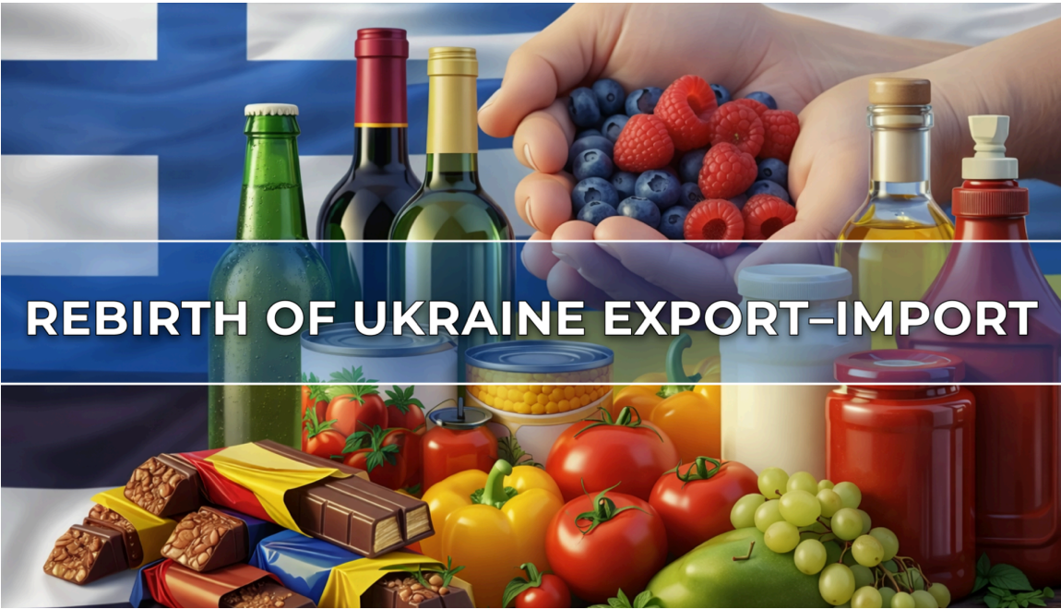

Dear Procurement Team,

I believe it may be unnecessary to elaborate on the current situation in Ukraine and how important it is to support the country in every possible way. One of these ways is through the consumption of Ukrainian products. At Business Finland, we see this as a meaningful avenue to contribute — by strengthening trade relations and supporting Ukraine through economic cooperation.

On behalf of the REBIRTH UKRAINE Trade Mission to Finland, we are
proud to present a curated portfolio of high-quality, EU-compliant food
products from leading Ukrainian manufacturers participating in the official
Trade Mission delegation.

Our participants combine competitive pricing, internationally certified
quality and flexible private label capabilities, making them reliable and
attractive suppliers for the European market.

As part of the Trade Mission, the delegation will participate in a series of
scheduled events. We warmly invite Finnish retailers,
distributors, importers and HoReCa professionals to join these
activities, including degustation sessions and B2B matchmaking
meetings.

This is a unique opportunity to establish direct connections with export-
ready Ukrainian producers and explore new sourcing opportunities tailored to EU market needs.

Location: Helsinki, Original Sokos Hotel Presidentti Helsinki
Date: May 7, 2026
Event: Global Forum of REBIRTH UKRAINE Trade Mission - UA-FI Economic Recovery Business Forum - Ukraine-Finland Trade Connect Zone (from 8:30 till 16:00)
The Ukraine-Finland Trade Connect Zone as an important part of UA-FI Economic Recovery Business Forum on May 7, 2026 will include:
– Pre-scheduled B2B matchmaking meetings (8:30-11:00)
– Product presentations and tasting sessions (11:00-13:00)
– Direct sourcing discussions with decision-makers & Networking (13:00-16:00)

Free Entrance – preliminary registration
https://forms.gle/vVTbVgpcLdEW9xY1A

Book your meetings in advance to unlock new sourcing opportunities
and connect with trusted Ukrainian suppliers ready for the EU market.

B2B schedule here:

https://docs.google.com/spreadsheets/d/1s8Tj1a808bdxKSvxUer-VuCf2ybcw7wT/edit?gid=1468850466#gid=1468850466

We believe this may be a valuable opportunity for your team to explore new sourcing partnerships tailored to the Finnish market.
The best way to support Ukraine is to work with Ukrainian partners!

Explore the Premium Ukrainian Food & Beverage Portfolio
You can see Presentations of the product for the following link - Premium
Ukrainian Food & Beverage Portfolio https://drive.google.com/drive/folders/1TfUCxmxOyFkyLL-uR4YVgD-zabt9MgGO

Organic Honey
Premium organic honey (monofloral & acacia) with EU-BIO certification.
Ideal for retail shelves, specialty stores, and private label programs.
Consistent supply, traceable origin, and strong consumer demand for
natural products.

Vegan Snack Bars & Chocolate bites
Functional, gluten-free snack bars with no added sugar - perfect for
health-conscious EU consumers. Dark chocolate nut bites - delicious and
nutritious snacks. Chocolate nut bites combine the rich flavor of dark
chocolate with the health benefits of nuts. Modern packaging and strong
positioning for retail chains and e-commerce channels.

Vegan Energy & Fruit Bars
Bars are high-quality, functional vegan snacks combining clean
ingredients, great taste, and strong on-trend positioning - gluten-free, no added sugar, and ideal for growing demand in the EU healthy snacking segment.

Organic Cereals & Grains, Organic Honey, Organic corn sticks,
Organic Sunflower Oil
A full range of organic cereals including barley groats, pearl barley, Arnaut
wheat groats, wheat groats, millet, semolina, steamed buckwheat, green
buckwheat, spelt, Original oat flakes. High demand category of healthy
and sustainable eating trends.
Organic herbal honey & acacia honey.
Corn sticks with freeze-dried berries are crispy snacks with heavenly
berries inside. These are the first and only organic sticks made in Ukraine
and are certified in accordance with European organic standards. Their
totally natural composition makes them a healthy alternative to sweets.
Organic Extra Virgin cold-pressed organic sunflower oil in Retail package

Sunflower Oil, Sauces & Mayonnaise
Sunflower oil refined deodorized winterized of P grade in Retail package.
HoReCa solution includes Sunflower oil refined deodorized winterized of
P grade with antioxidant and antifoaming agent, 5l, PP bottle. Competitive
pricing and scalable supply for retail and food service sectors.
Wide range of mayonnaise, sauces, ketchup and mustard tailored for
retail and HoReCa. Reliable quality and flexible packaging formats.

Beverages wines
Premium Ukrainian wines from Transkarpatia, Unique Eastern European
positioning with growing demand in EU markets.

Beverages craft beers, kombucha, soft drinks
Premium Ukrainian craft beers, kombucha, and soft drinks. Unique
Eastern European positioning with growing demand in EU markets.

Dry Egg Powder Products (B2B)
Industrial-grade egg powders and liquid eggs for food manufacturers.
Large-scale, vertically integrated production ensures stable supply and
cost efficiency.

BEST FIT FOR:
EGG WHITE POWDER, HIGH GEL - Suitable for the confectionery,
bakery and meat industry, for production of crab sticks.
EGG WHITE POWDER, HIGH WHIP - Suitable for the confectionery
and bakery industry
EGG YOLK POWDER - Suitable for mayonnaise, dressings, pasta,
ice cream, baked products, cake mix or other products where egg
yolk ineeded.
HEAT-STABLE EGG YOLK POWDER - production of mayonnaise
WHOLE EGG POWDER - Suitable for baked products, ready meals,
meat products
FROZEN LIQUID WHOLE EGG - Suitable for confectionery and
baked products, ready meals, dressings etc.
_____________________________________________________

Why Partner With Us?
Full EU compliance and international certifications
Competitive pricing vs Western European suppliers
Private label and customization options
Reliable logistics and export experience
Strong product-market fit for Dutch and EU consumers
_____________________________________________________

Product Portfolio Overview (Ukraine suppliers| EU-Compliant)

1. Organic Natural Honey
MED UKRAINY (Organic Export LLC)
One of Ukraine’s leading organic honey producers
Full range: monofloral honeys, premium lines, private label
Certification: EU-BIO

Best fit: Retail | Distributor | E-commerce | HoReCa | Private Label
EU compliant: Yes

TM ECOROD (Organic Original LLC)
Organic herbal honey & acacia honey
Produced in ecologically clean regions
Certification: EU-BIO
Best fit: Retail | Distributor | E-commerce
EU compliant: Yes

2. Sweets & Natural Bars
BARGY TM
Functional vegan snack bars
Gluten-free, no added sugar
Certification: ISO 22000
Best fit: Retail | Distributor | E-commerce | HoReCa | Private Label
EU compliant: Yes

3. Organic Cereals & Porridges
TM ECOROD (Organic Original LLC)
Pioneer in Ukraine’s organic food market
Product range:
-Barley groats, pearl barley
-Wheat groats (incl. Arnaut)
-Millet, semolina
-Buckwheat (steamed & green)
-Spelt
-Oat flakes

Certification: EU-BIO
Best fit: Retail | Distributor | E-commerce | HoReCa | Private Label
EU compliant: Yes

4. Sunflower Oil
DELTA FOOD LLC (TM Gulyai-pole)
Refined deodorized winterized sunflower oil
Available in: 1L, 1.8L, 3L, 5L (PP bottles)
Variants with antioxidant & antifoaming agent
Certification: ISO 22000
Best fit: Retail | Distributor | E-commerce | HoReCa | Private Label
EU compliant: Yes

TM ECOROD (Organic Original LLC)
Organic cold-pressed sunflower oil
Awarded Best Organic Product in Eastern Europe (2013, Warsaw)
Certification: EU-BIO
Best fit: Retail | Distributor | E-commerce
EU compliant: Yes

5. Sauces & Condiments
DELTA FOOD LLC (TM Gulyai-pole)
Product range:
-Mayonnaise & mayonnaise sauces
-Ketchup
-Mustard
Packaging for Retail & HoReCa
Certification: ISO 22000
Best fit: Retail | Distributor | E-commerce | HoReCa | Private Label
EU compliant: Yes

6. Beverages
CHATEAU CHIZAY
Premium winery (est. 1995, Zakarpattia)

272 hectares of vineyards, exports to 20+ countries
Products:
-Sparkling wines (Chersegi, Blaufrankisch, Brut)
-Red wines (Cabernet, Cuvée)
-White wines (Chersegi, Gewürztraminer, Furmint)
-Dessert wines & semi-sweet wines
-Cherry liqueur & walnut tincture
Best fit: Retail | Distributor | HoReCa

VOLINSKI BROWAR
Modern beverage producer exporting across Europe
Brands: Volynski Browar, Mikki Brew, Forever
Products:
-Craft beer (Weisse, Ale, Lager, Porter, Stout, etc.)
-Cider
-Kombucha
-Bubble tea
-Energy drinks & vitamin water
-Lemonades
Certification: ISO 22000
Best fit: Retail | Distributor | E-commerce | HoReCa | Private Label
EU compliant: Yes

7. Dry Egg Products
AVANGARD / Imperovo Foods
-Leading producer in Ukraine (66% market share)
-Advanced processing facility (since 2007)
-Capacity: 6 million eggs/day (planned 10 million)
-Fully vertically integrated (own poultry farms)
Product Range
-Egg white powder (high gel / high whip)
-Egg yolk powder
-Heat-stable egg yolk powder
-Whole egg powder
-Frozen liquid whole egg

Applications
-Bakery & confectionery
--Meat processing
Sauces & dressings
-Ready meals
Certifications
ISO 9001:2015
ISO 22000
FSSC 22000
HALAL
Best fit: Food industry manufacturers
EU compliant: Yes
_____________________________________________________

Key Strengths Across Portfolio
Strong EU compliance across all categories
Wide private label capabilities
Multiple international certifications (EU-BIO, ISO, IFS, FSSC,
HALAL)
Suitable for Retail, HoReCa, and industrial buyers
Competitive sourcing from Ukraine’s agricultural base

Other individual meeting options:
📍 Location: Tallin, Estonia - Date: May 11, 2026
📍 Location: Riga, Latvia - Date: May 13, 2026
📍 Location: Vilnius, Lithuania - Date: May 14, 2026

For more questions, please contact us:
Olena Kaijen, Director of ALLE FOOD UA & Co-organizer of the sectoral
Trade Missions REBIRTH UKRAINE | EXPORT-IMPORT
📞 Phone/WhatsApp: +38 (067) 504 4990
📩 Email: allefoodua@gmail.com

